**IDEATION PHASE**

**Step:1**

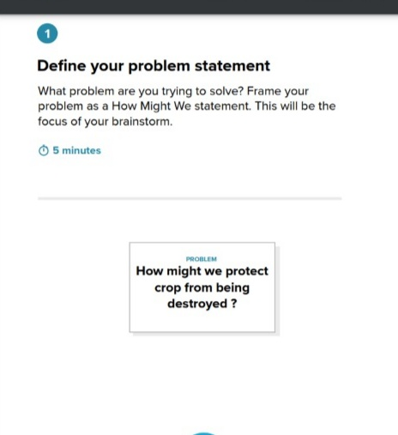

**Step: 2 Brainstorm, Idea Listing & Grouping:**

**BRAINSTORM:**

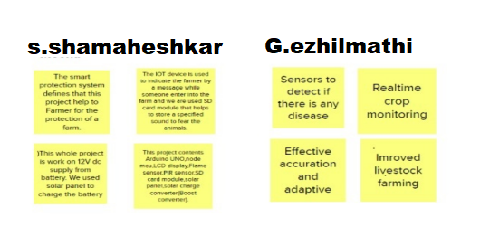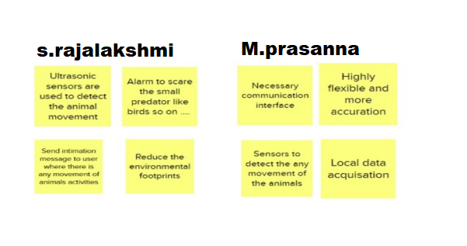

**GROUP IDEAS:**

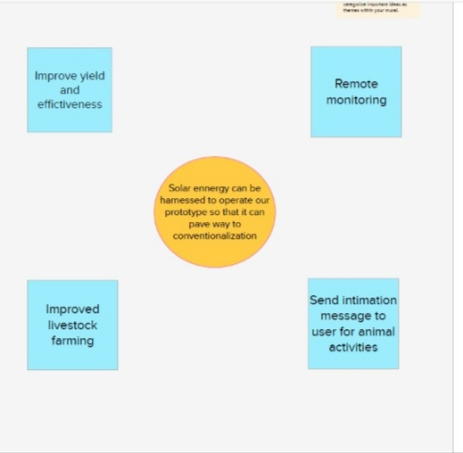

**Step:3**

**IDEA PRIORITIZATION:**

